**Using @IdClass**

In this method, we create a composite class (primary key) with all the required primary key attributes. However, we do not annotate this class, so it remains a plain java class.

Here’s the definition:

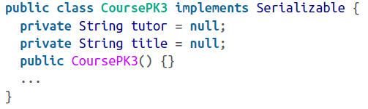

Now we need to declare the main entity with the additional class-level annotation @*IdClass.* This refers to our composite primary key class.

When it comes to the main entity class, there is a disadvantage of following this path. We need to duplicate key identifiers (*tutor* and *title)* an our main class too in this method. They must be decorated with @*Id.*

See the class definition of our main entity class here:

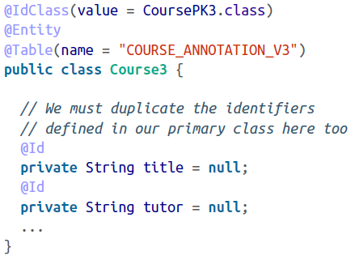

Using the @IdClass method for defining the composite key is not a statdard practice and is best avoided. I suggest you pick either of the first two methods instead.